Project Plan Template
Overview
Project name
Project manager
Approval authority
Project team
Helpers
Project vision/objective
Start date
Completion date

Project time management
Break the objective into sub-objectives
Use this structure as a guideline.

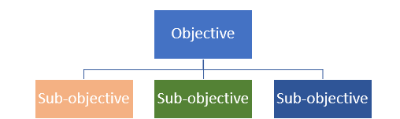

Break the sub-objectives into tasks
Use this structure as a guideline.

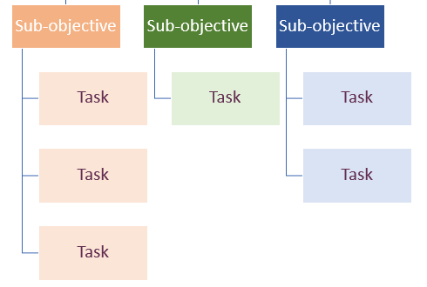
Set due dates per task
Use this structure as a guideline.

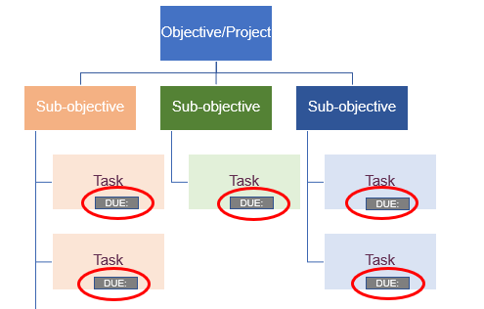

Order of completion of tasks
Use this structure as a guideline.

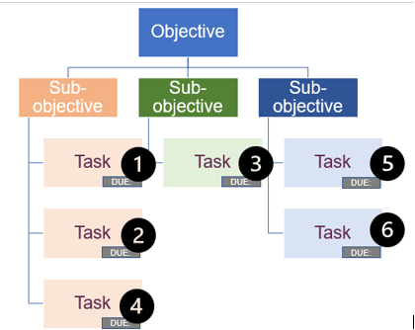
Determine start and end-dates, and allocate tasks to team members
Use this structure as a guideline.

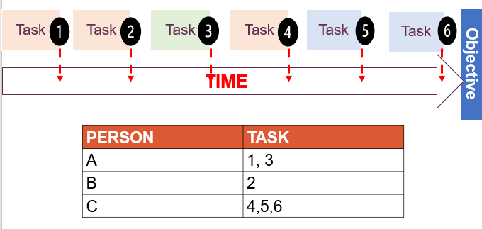

Reporting
Who and to whom?
What?
Measured against?
Format
Frequency

Project scope management
Consider where scope changes might be required.
Decide what the process will be to get approval for any changes in scope. Will there be a written request to the approval authority?
Will scope changes only be allowed once it has been signed off by the approval authority?
What other processes can be put in place to ensure your project remains on track?
What else?

Project risk management
Prepare a risk register in the following template.
Risk | Likelihood of risk | Action to prevent risk from occurring | Action plan for risk | Person responsible

Project procurement management
Identifying procurement needs
List of products | List of services

Procurement management
What we know
What we need to find out
How will we manage the procurement process?

Project cost management
Create a budget and include it in your plan
Consider the following before you create your budget.
Who will develop the budget?
Who will authorise the budget?
Who will monitor the budget?
Who will confirm changes to the budget?

Project quality management
Expected standards
What we know
What we need to find out
What are our expected standards
Quality
What is the priority of quality for our project?
What do we know about how to approach quality monitoring?
What do we need to find out?
What will our approach be to monitor quality?

Monitoring and evaluation systems
Monitoring
What format will the monitoring report be in?
How often will it be done?
Who will be the recipient of the monitoring report?
What follow-up mechanisms will there be?
Evaluation
Who will do the evaluation?
What objective will the project be evaluated against?
What will happen to the report?

Evaluating your Project Plan
Project scope management | Y/N
Importance of scope management: The Implementation Plan includes at least two reasons why scope management is important.
Approach to monitor and control scope changes: There is a logical process for monitoring and controlling scope, based on the parameters of project.
What falls into the project scope: There is a work breakdown structure (WBS) that is structured in a logical way. Activities are clearly broken down into different phases, and no activities are left out of the WBS.
Project time management
There is a detailed final schedule. All activities identified in the WBS are included. The schedule shows how long each activity will take, when each activity will start, when each activity will end, and when the project will end.
Changes to the schedule: There is a logical process for monitoring and controlling changes to the schedule, based on the parameters of project.
Project cost management
Final project budget: The budget has a reasonable cost associated to every activity, and each activity in the WBS is included in the budget.
Roles and responsibilities: All relevant roles and responsibilities have been suitably allocated.
Reporting format: The reporting format is logical and practicable.
Variance responses: Appropriate processes have been identified.
Change control: Appropriate processes have been identified.
Project quality management
Industry standards: Relevant industry standards have been included. Evidence of research into similar projects is present.
- Quality priority: Quality has been prioritised accordingly.
- Roles and responsibilities: All relevant roles and responsibilities have been suitably allocated.
- Approach to be used to monitor and control quality: Appropriate processes have been identified and elaborated on accordingly.
Project risk management
- Risk register has been completed with evidence of understanding of risks and risk mitigation.
Project procurement management
- Identifying procurement needs: Procurement needs match up to activities identified in the WBS and have been classified appropriately as either products or services.
- Managing the procurement process: Appropriate processes have been identified and elaborated on accordingly.

